Data Flow Orchestration

**Tools Used:**

* Talend7.3 for BigData
* MongoDB Compass
* Studio3T

**MongoDB**

Configured MongoDB database on VM machine and created database demoDb01.

**Dimension table load**

Created CSV file from provided DML statements, created metadata for each dimension, created job to load dimensions data and loaded all dimensions data into MongoDB using below Job.

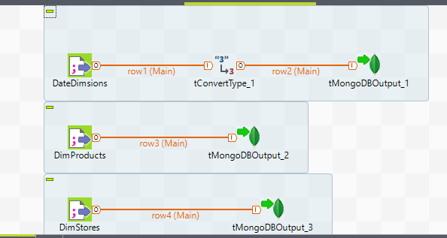

For DateDimensions table, used tConvertType to convert date format from file to load into MongoDB.

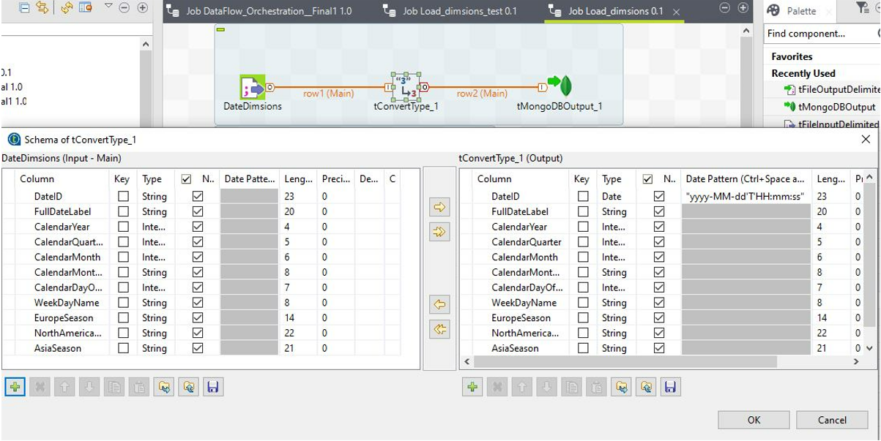

**Orchestration Flow for FactStore**

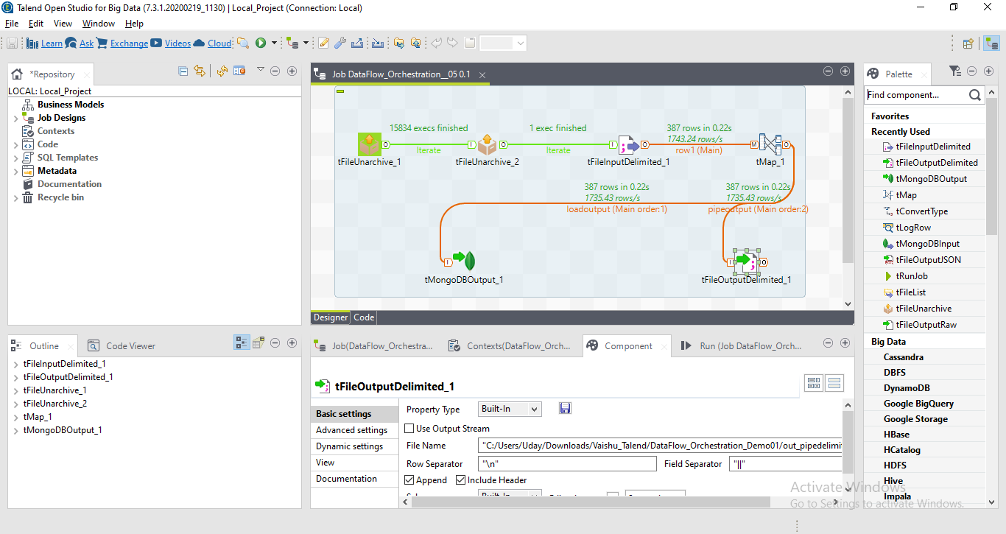

Components used:

* tFileUnarchive_1
* tFileUnarchive_2
* tFileInputDelimited
* tMap
* tOutputFileDelimited
* tMongoDBOutput

**tFileUnarchive _1**

Below component used to extract zip file, 2009.zip into directory.

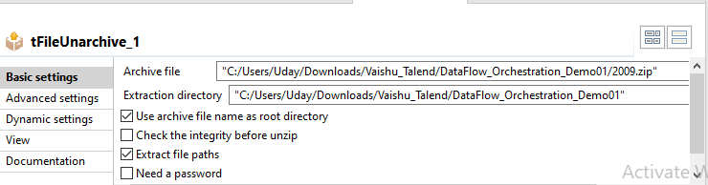

**tFileUnarchive _2**

This component used to extract zip file under each sub folders.

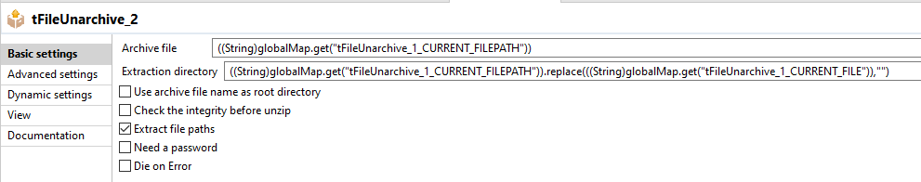

**tFileInputDelimited**

Split the column on each row from each file using tab delimiter and output is passed to tMap.

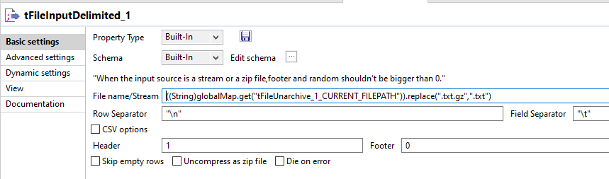

**tMap:**

Map input from FileInputDelimited component to two outputs

* loadoutput – to load into mongoDb
* pipeoutput – to write into outputfile with pipe delimiter

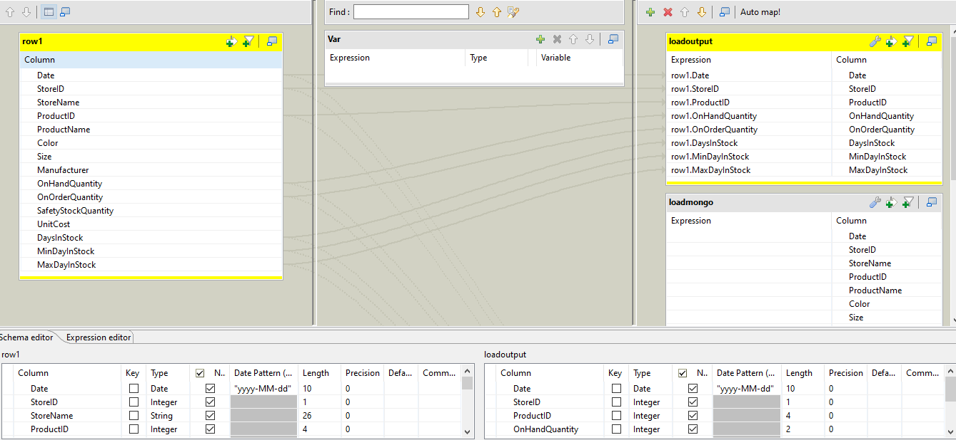

**tOutputFileDelimited:**

This component reads output from tMap and write into file with pipe delimiter with only selected columns.

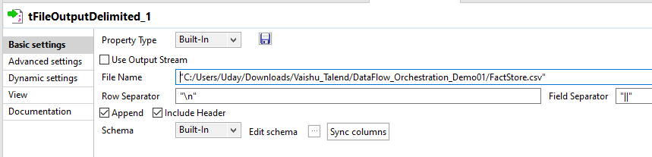

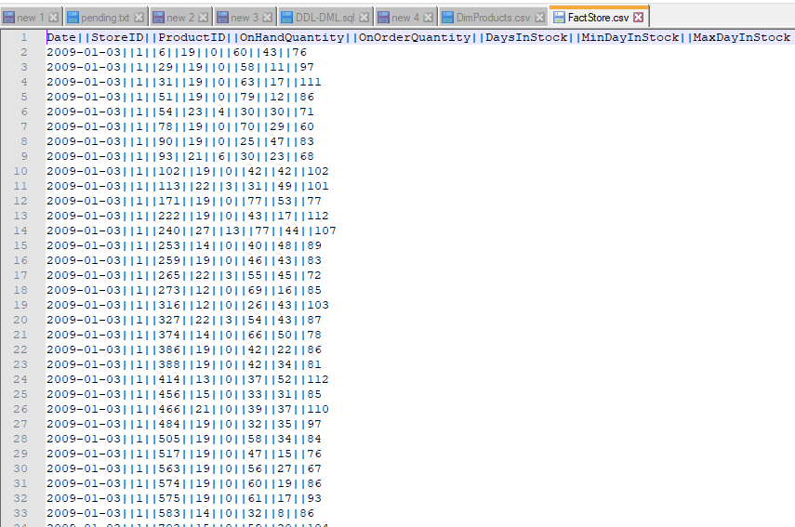

**tMongoDBOutput:**

This component loads processed factStore data into mongoDB. MongoDB detailed are stored as metadata.

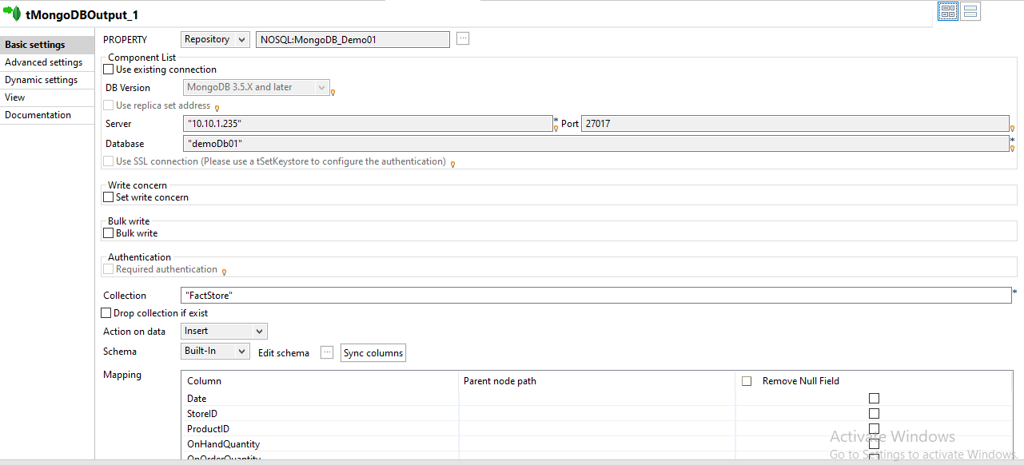

::

**MongoDB collections visual on DB Compass & INDEX created for KEY COLUMNS**

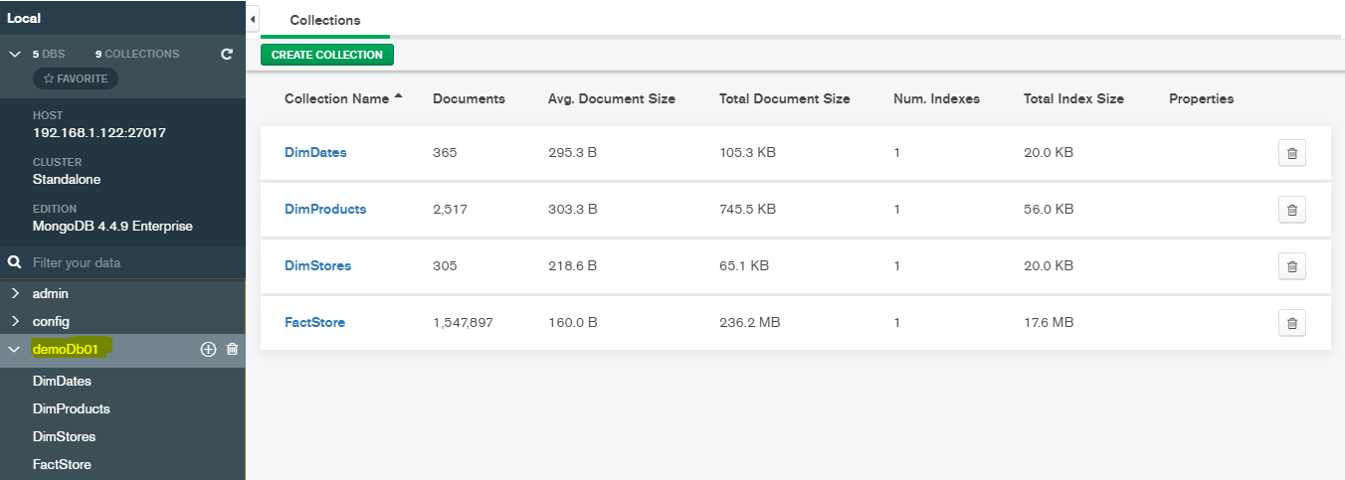

Overall Assessment is Exported as HTML



**Query ResultSet :**

Used studio 3T to generate mongo shell query to get result set.

**Index Creation on Key columns:**

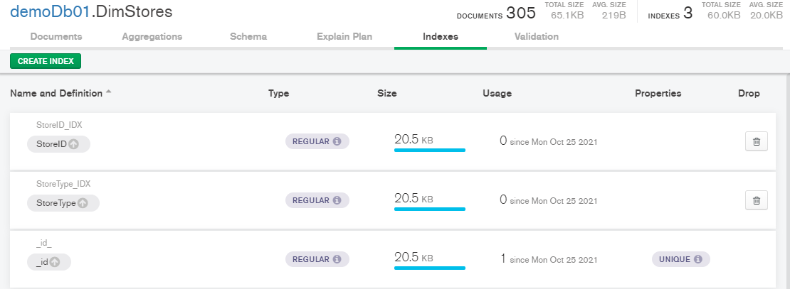

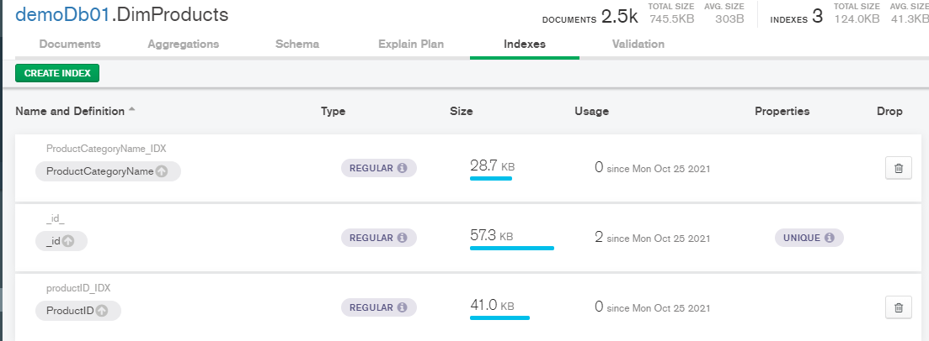

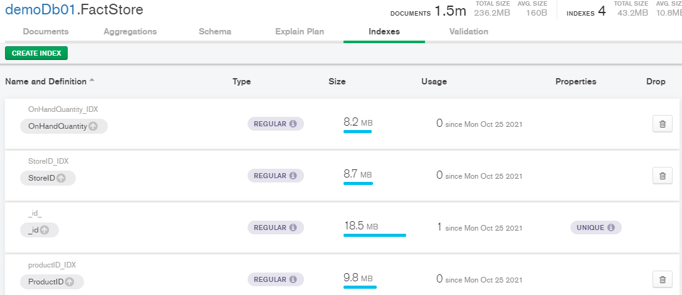

1. Finding the Average number of stocks on hand by Category

Mongo Query n Mongo output n mongo expected output

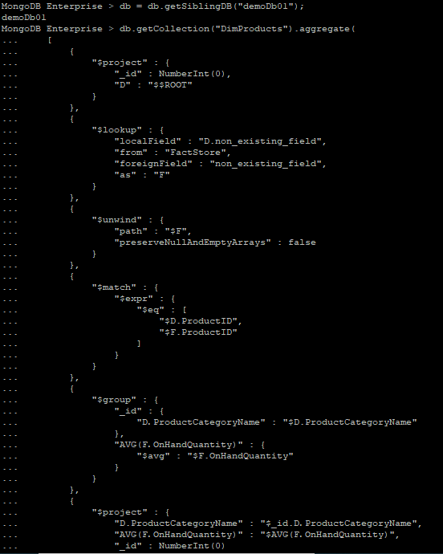

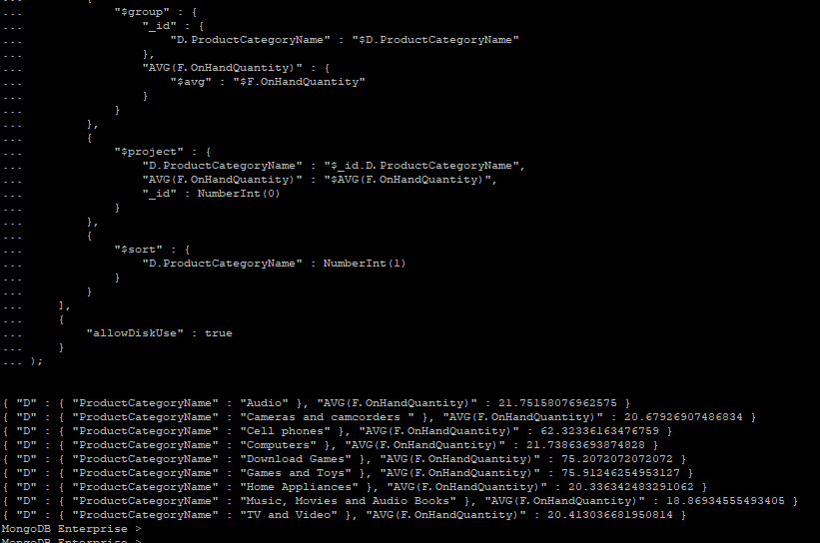

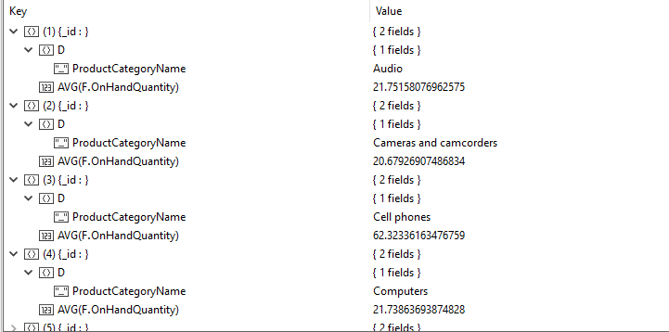

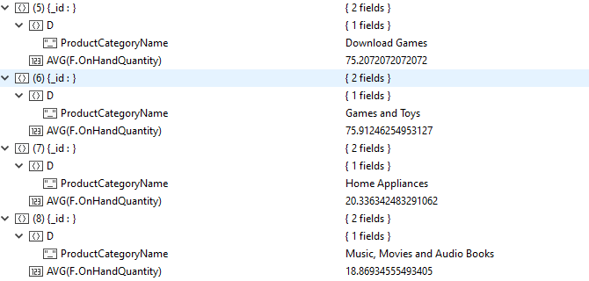

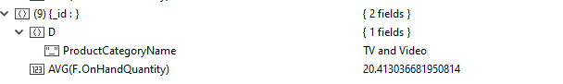

1. Finding the Average number of stocks on hand by store.

Mongo Query n Mongo output n mongo expected output

